**1)Find all the topics and tasks which are thought in the month of October ?**

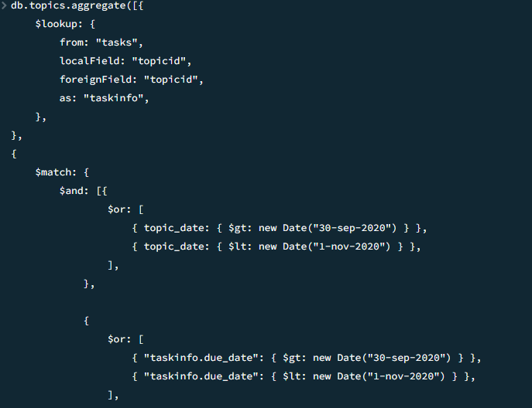

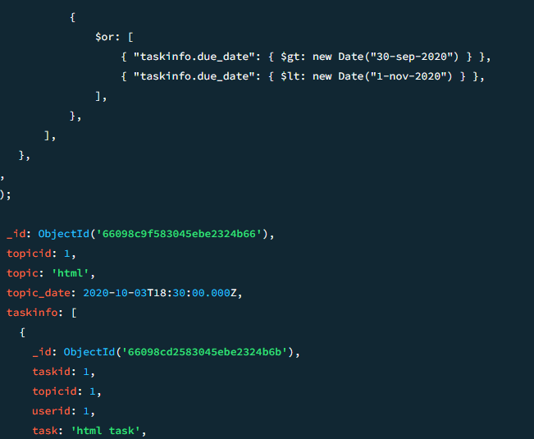

**2)Find all the company drives which appeared between 15 oct-2020 and31-oct-2020?**

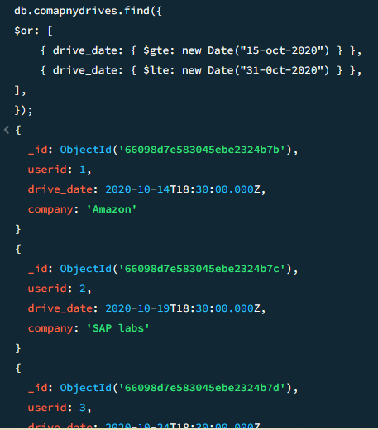

3) **Find all the company drives and students who are appeared for the placement.?**

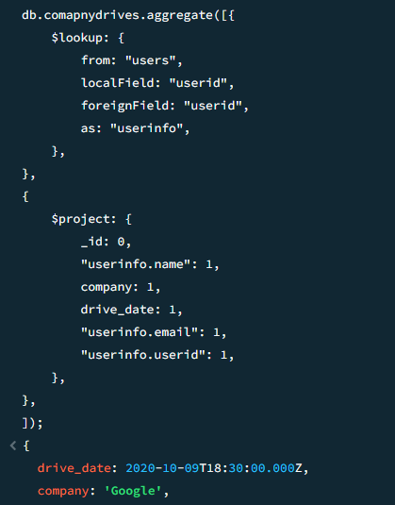

4) **Find the number of problems solved by the user in codekata.?**

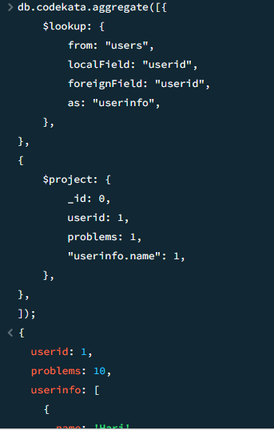

5)**Find the number of users who are absent and task is not submitted between 15 oct-2020 and 31-oct-2020.?**

